1. Histograms for all columns in the training data :A graph of different types of houses

   Description automatically generated with medium confidence

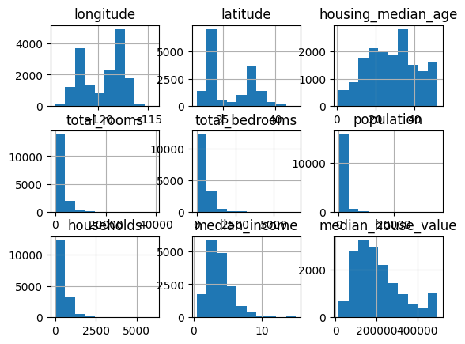

1. Generating histograms with a specified figure size for better visibility

1. Encoding categorical variables and generating a correlation heatmap

1. Generating histograms again to visualize the distribution after logarithmic transformation

1. Calculating correlations again with the encoded data

1. Visualizing the geographical distribution of median house values using a scatter plot

1. Calculating and visualizing the correlation matrix with the new features included

